CTO LAB
KONY 7380 W SANDLAKE RD, ORLANDO
KONY FABRIC – OAUTH –ALEXA INTEGRATION Steps

Steps below explain, how to integrate an OAuth based connection with Amazon Alexa and Kony Fabric by adding an Alexa skill into your AWS console that is authenticated using a Kony companion app and Kony Fabric as the OAuth endpoint.

Step 1:

Download the “accountant” app from Kony marketplace. Login to Kony Fabric, click on apps, click on import and choose the downloaded “accountant” app. App will appear in your account.
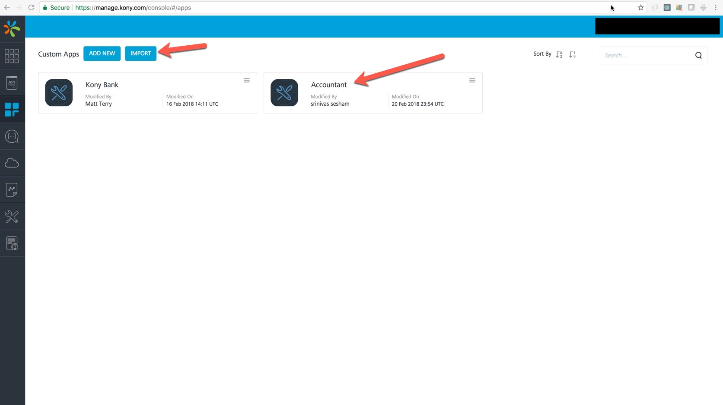

Step2: Click on the app and go to “Identity” tab, you should see 2 entries like below. Click on Kony User Repository
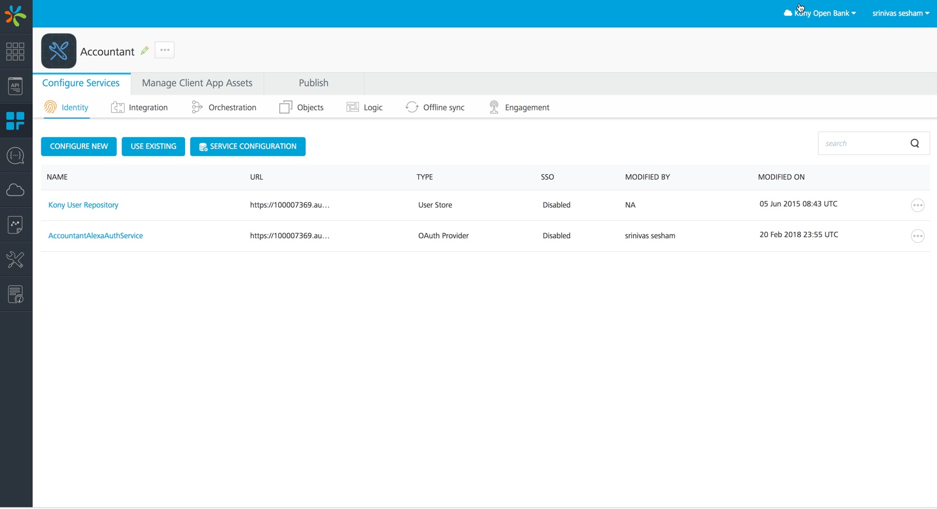

Step3: Click on Add user to create a user for OAuth, make a note of the credentials, you will be using these credentials during account linking of the Alexa Skill

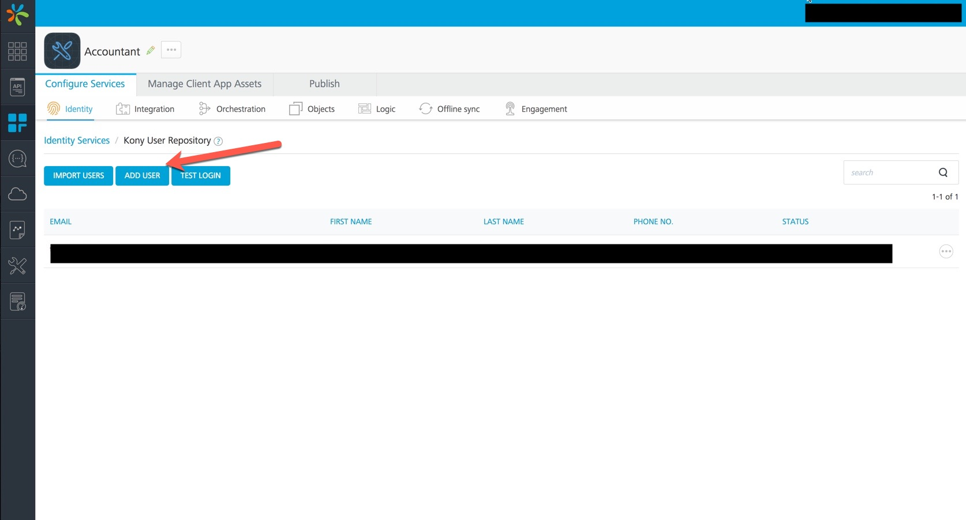Step4: Under Identity click “AccountantAlexaAuthService” and note down the “token endpoint”, “Authorization Endpoint”. You will need these details when you create the Alexa Skill.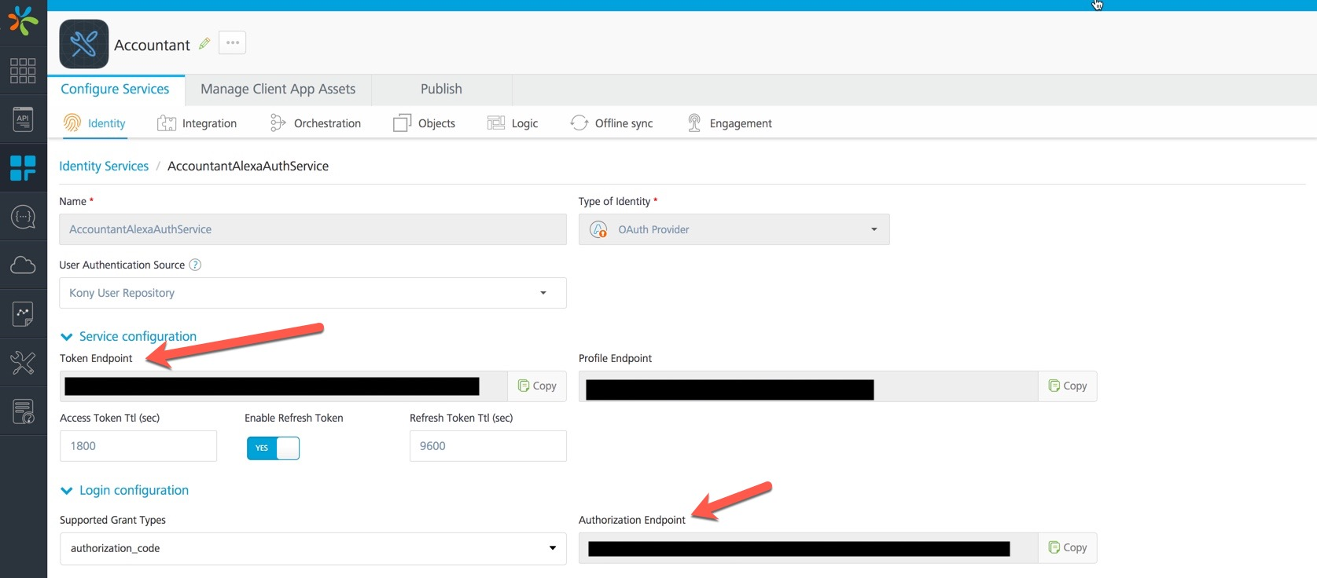

Step5: Click on Integration tab and make use the identity service for backend token is AccountantAlexaAuthService
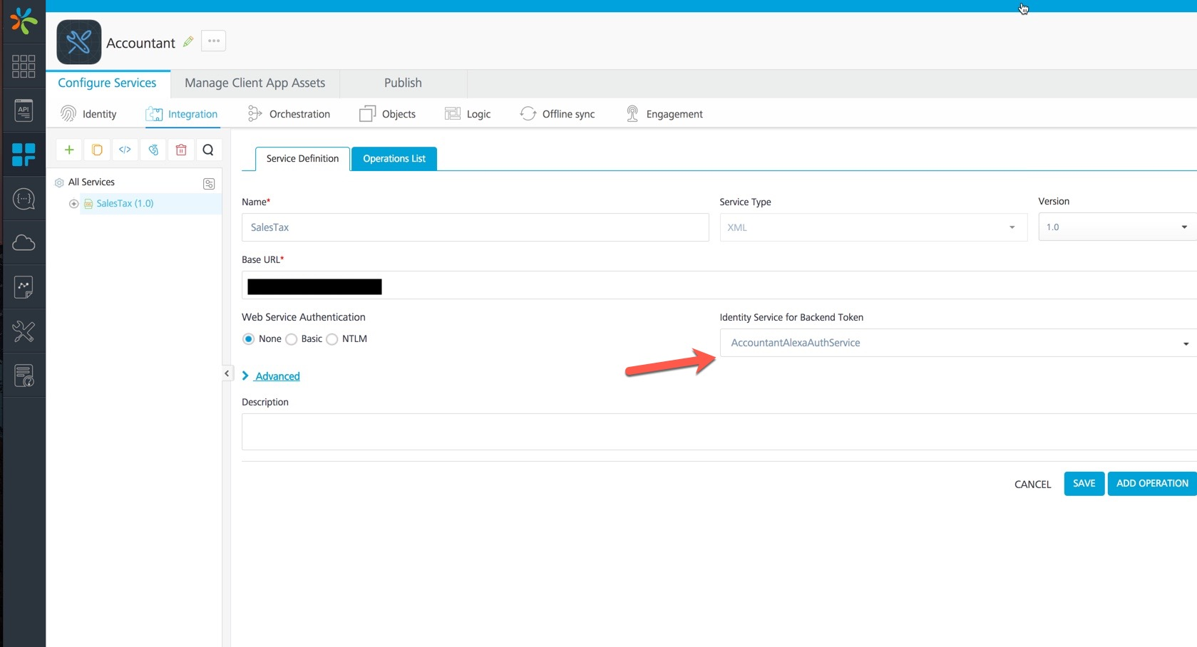

Step 6: Click on “publish tab”, select the environment you want the application to be published to. Click “Publish button”.
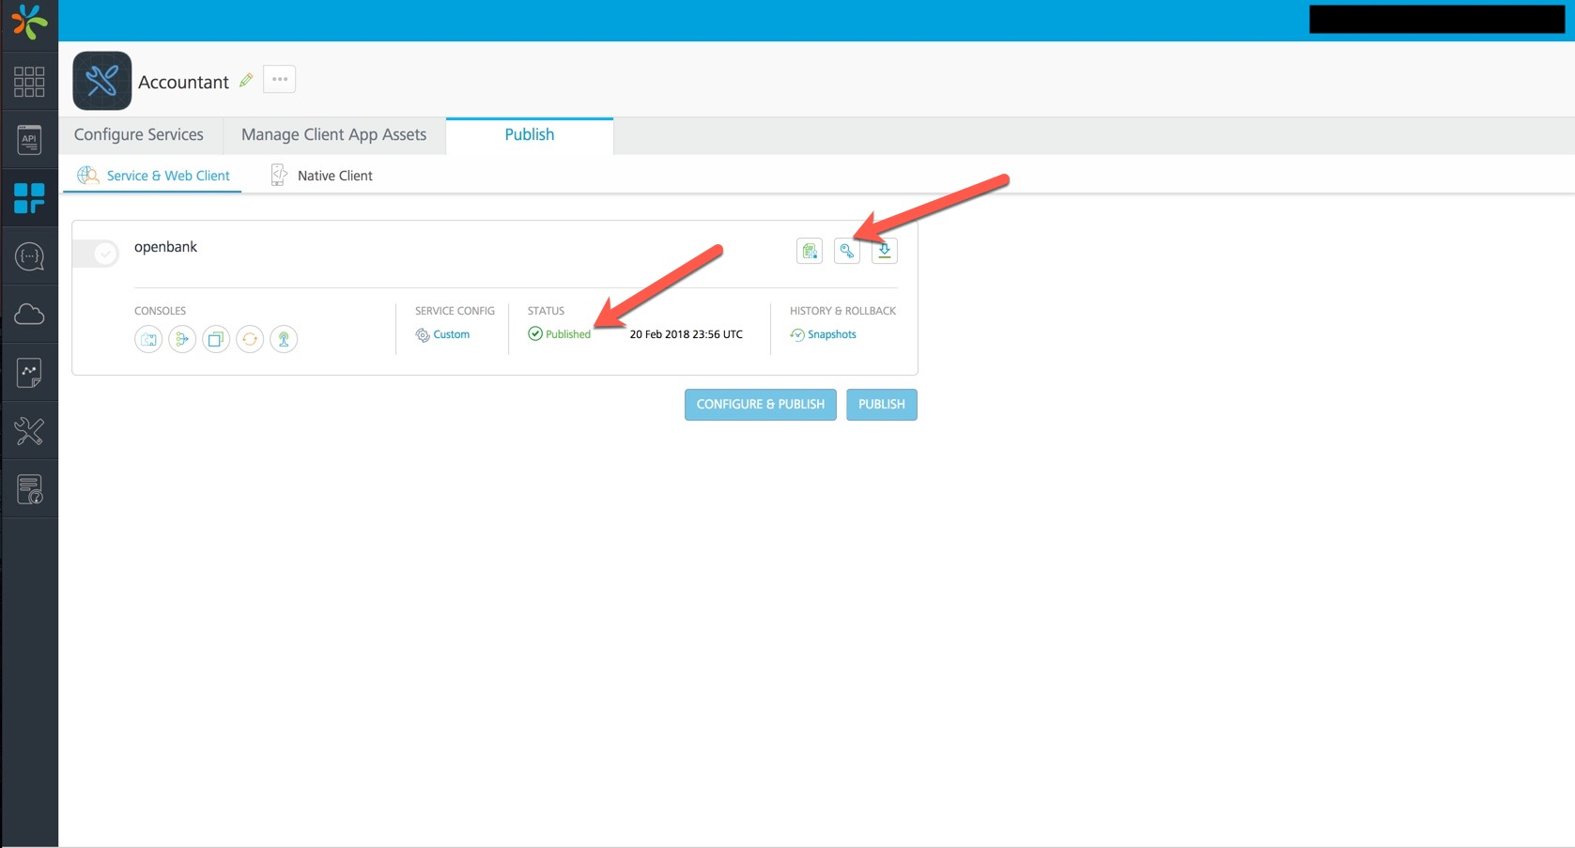

Step 7: You should see the app key, secret popup on successfully publishing the app. You can always click on the key icon to retrieve these details. Make a note of the app key /secret, you would need these while creating the Alexa skill.

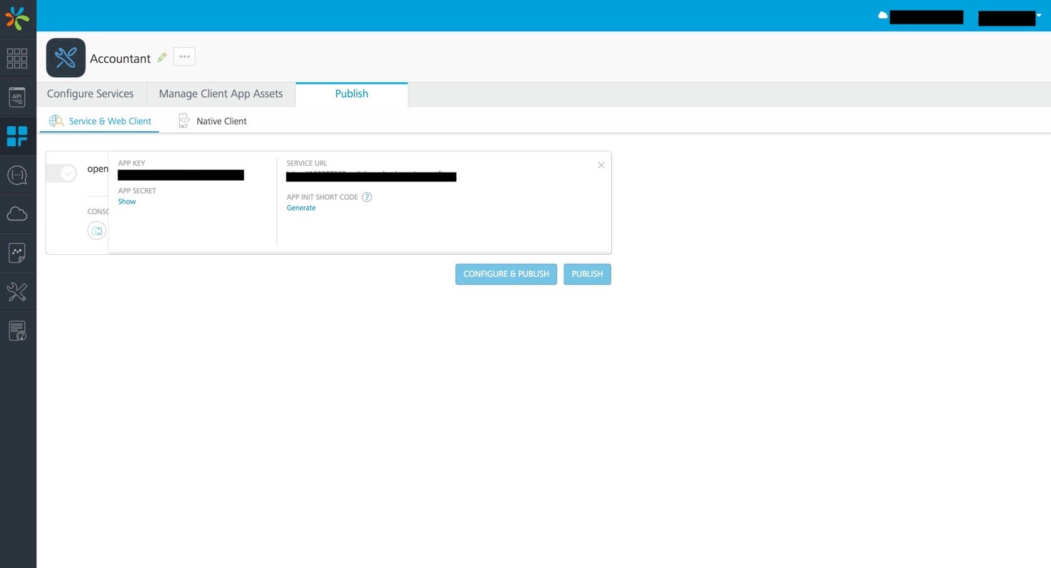

Step 8: Login to your account on AWS console portal and click on Lambda. Create a function ex: salesTaxSkill

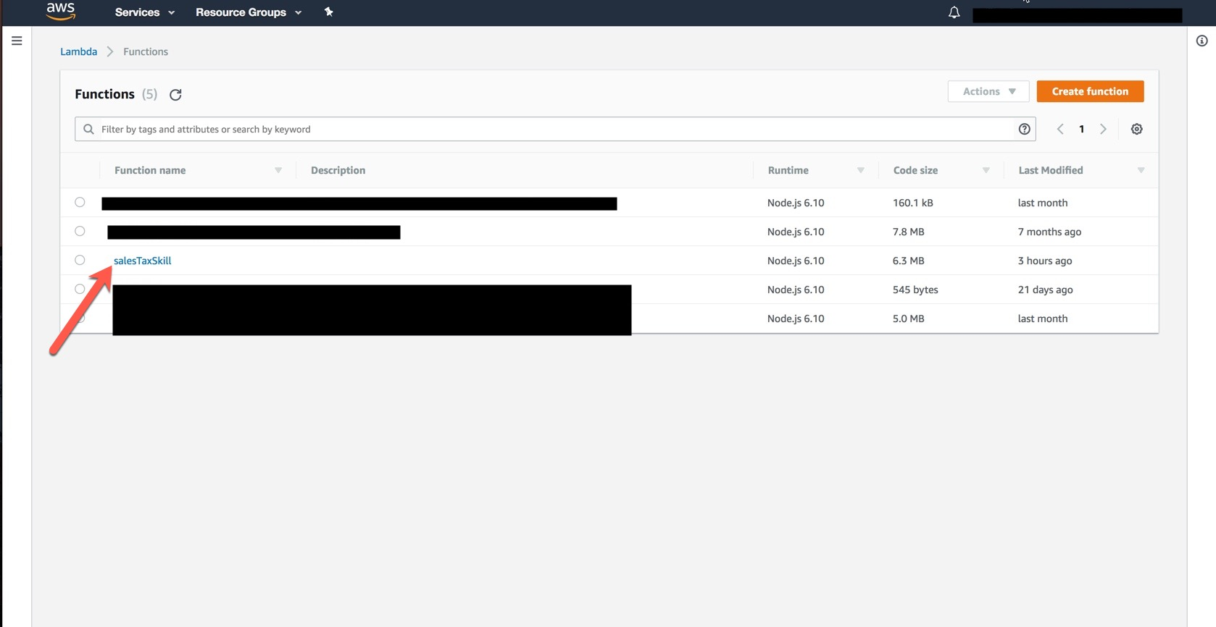

Step9: Your function configuration should like below. Make a note of the ARN on the top right corner, you will need while creating the Alexa Skill. Download lambda.zip from marketplace and upload it here by clicking upload a zip file under “Function code”. Save the function.

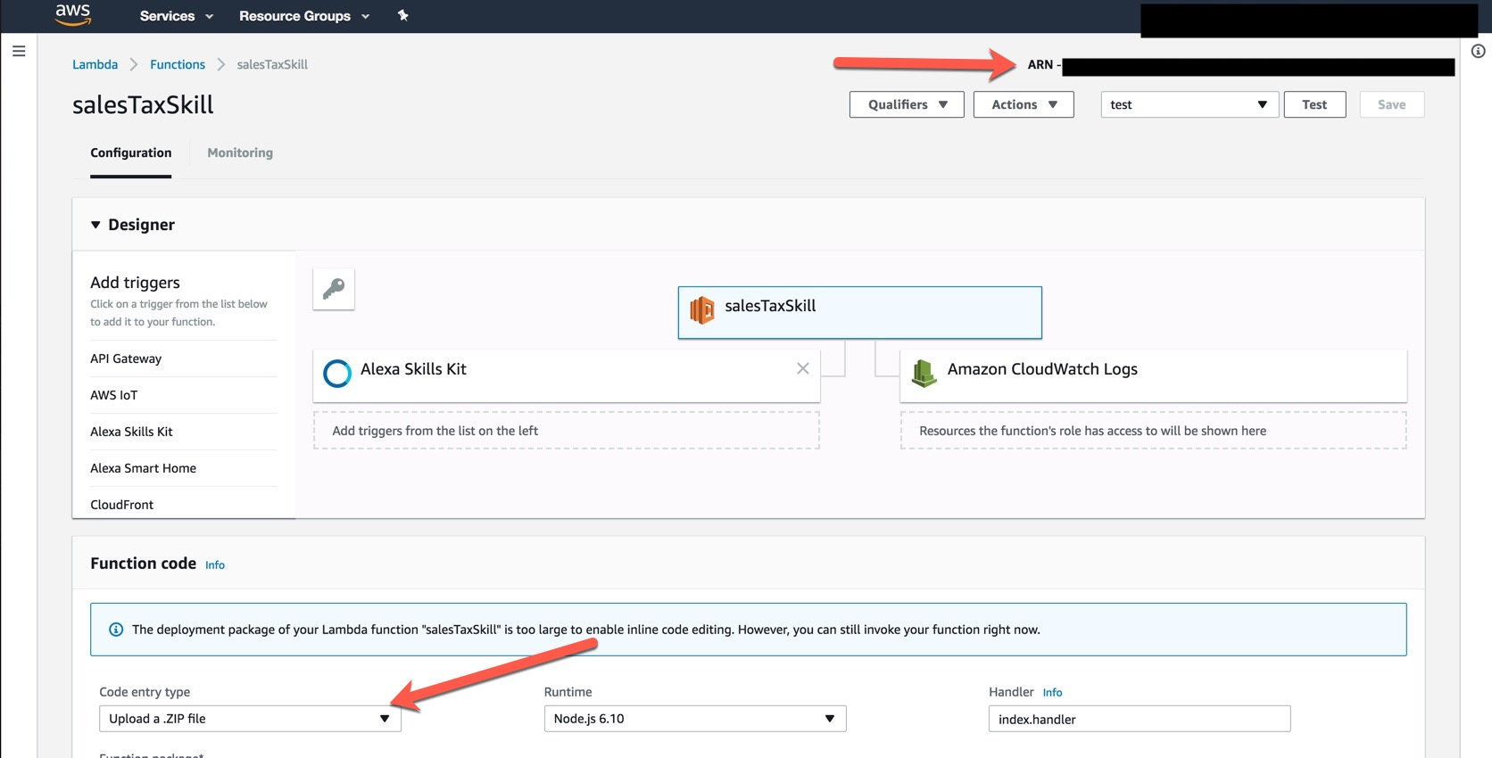

Step 10: Login to Alexa console portal. Create a skill Ex: Kony Accountant. Enter your lambda ARN (Noted in Step10) in Default text box. Enter Authorization URL and client Id (app key) from step 8.

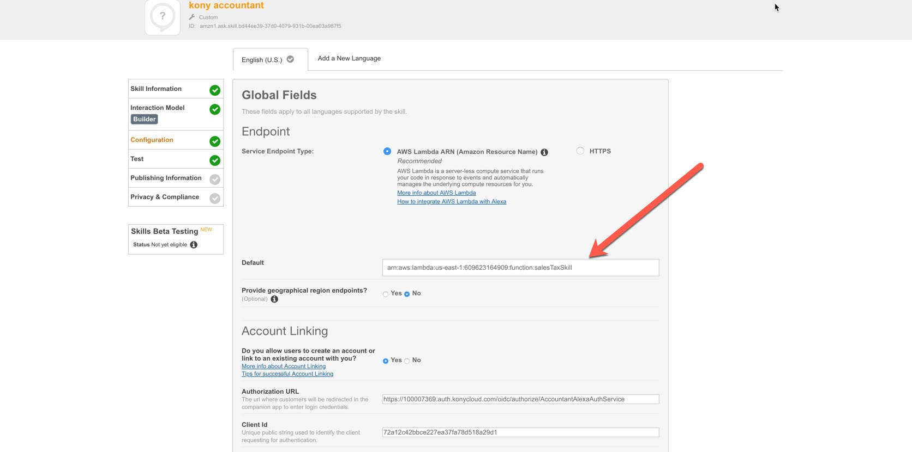

Step11: Enter Access Token URI, Client Secret from Step 8

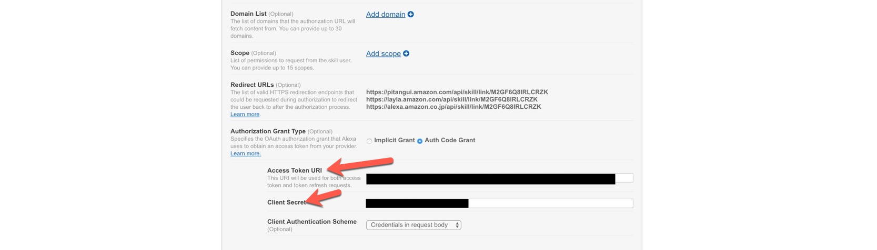

Step12: Go through the rest of the steps and click publish to get your skill certified.

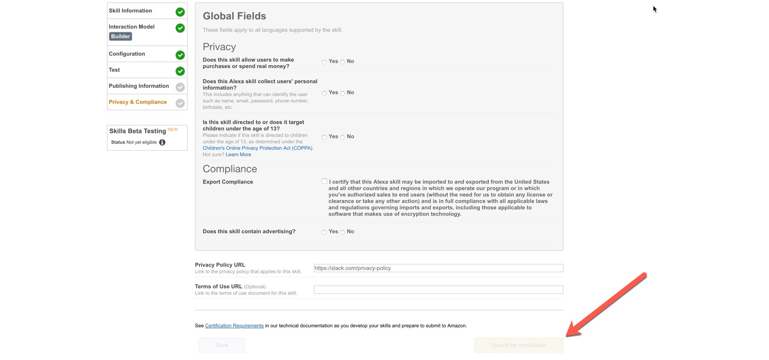

High level architecture
Description: The below diagram shows the design time tools used and also explains high level sequence of the steps a user goes through to add the Alexa skill, it also shows the responsibility of each of the components.

Design Time:
Kony Fabric Console: Is used to create the accountant application which will have the OAuth service.
AWS Lambda Console: Is used to create the Lambda Function which will be used from your Alexa Skill.
Alexa Skill Console: Is used to create the Alexa Skill. This is where you configure the skill to use Kony Fabric hosted OAuth provider.

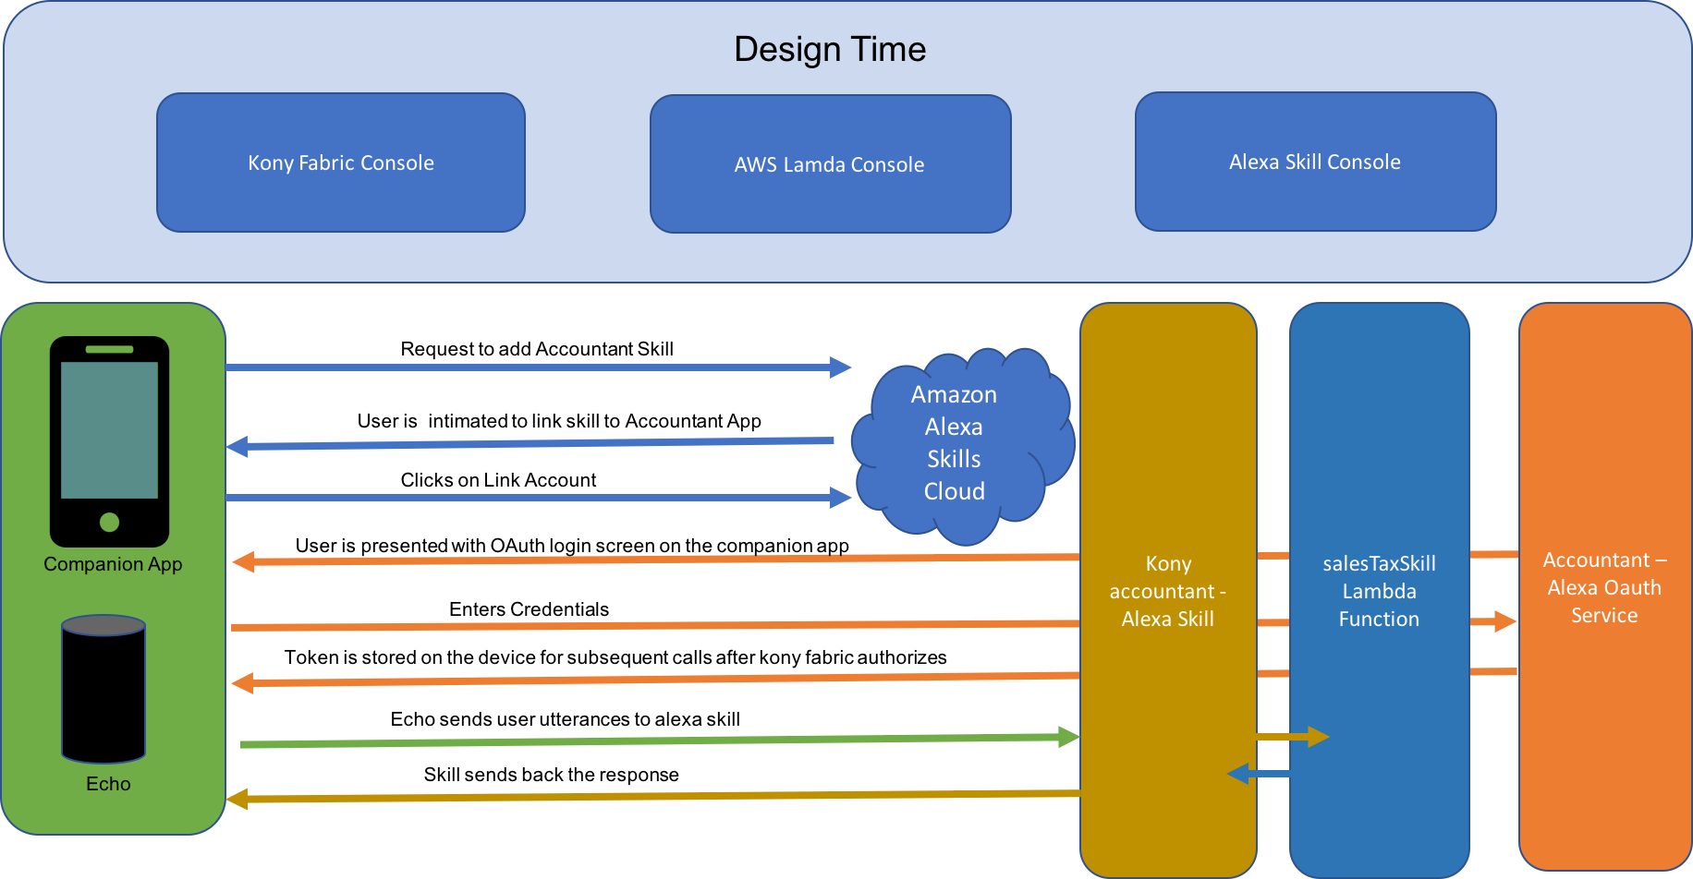
When a user tries to add the Alexa Skill, the typical steps followed are represented above.

- The user opens the Alexa companion app and selects the skill he wants to install.
- If the skill requires account linking (which is the case with our app), the user is presented with the OAuth login screen.
- User enters the credentials
- Kony Fabric authorizes the user and a token is sent back to the device
- Token is stored on the device and will be used in subsequent calls

